What is BMC?
A Baseboard Management Controller, or BMC, is an important component of server systems, including edge servers. It is a dedicated microcontroller or processor that is integrated into a server’s motherboard. It allows for remote control, management, and monitoring of the hardware, even when the system is powered off.
BMC is the core component of out-of-band management systems and allows system administrators to monitor and control servers remotely, even if the server is turned off or its OS is not functioning.
Main Features of BMC:
Features | Description
Power Management
  Power on/off/reboot the server remotely via a web interface or IPMI tools.
Hardware Monitoring
  Temperature, voltage, fan speed, PSU status, etc.
  Logging and Alerts
  Records events like over-temperature, fan failures, and sends alerts.
 | Update server BIOS or firmware without OS involvement.
  Firmware Updates
Remote management | Administrators can access and manage the server hardware remotely, even if the server is powered off or the main operating system is not running.
Example Use Case Scenario:
- A server in a data center crashes and becomes unresponsive.
- The OS cannot be reached via SSH or RDP.
- Admin connects to the BMC interface (e.g., Dell iDRAC or HP iLO) via web browser.
- Admin checks logs, finds CPU overheating.
- Admin reboots server remotely and limits CPU frequency via BIOS — all without going onsite.

In modern server platforms, the Baseboard Management Controller (BMC) acts as a dedicated microcontroller, providing remote management and monitoring capabilities for hardware components, even when the main operating system is offline or unresponsive. It enables out-of-band management, allowing administrators to access and control servers remotely, improving efficiency and reducing the need for physical intervention
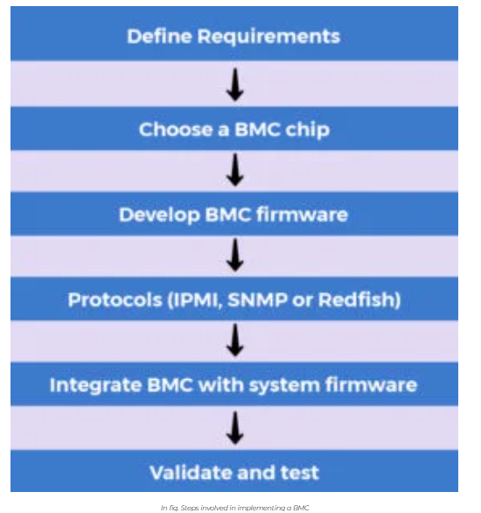
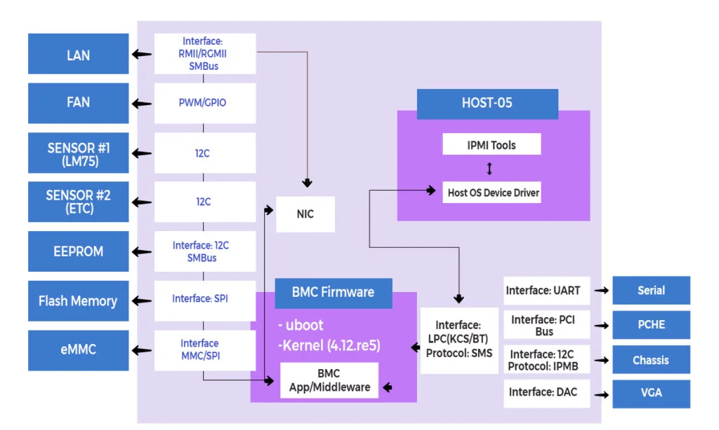

Out-of-Band vs In-Band Management:
Feature | In-Band Management | Out-of-Band Management
Access Path | Through main operating system and production network | Through a separate management channel (e.g., BMC)
Depends on OS | Yes (OS must be running) | No (works even when OS is down or server is powered off)
Common Tools | SSH, RDP, SNMP, remote desktop | BMC Web UI, IPMI, iDRAC, iLO, Redfish
Security | Same as system security | Has separate credentials and security policies
Use Case | Regular monitoring and administration | Emergency access, recovery, firmware update

https://www.logic-fruit.com/blog/general/simplified-server-management/?srsltid=AfmBOoowBD54NeqHlhoSJOG12zLGd9h954mIuuO0UoVy1oPqMd6rMs8O

